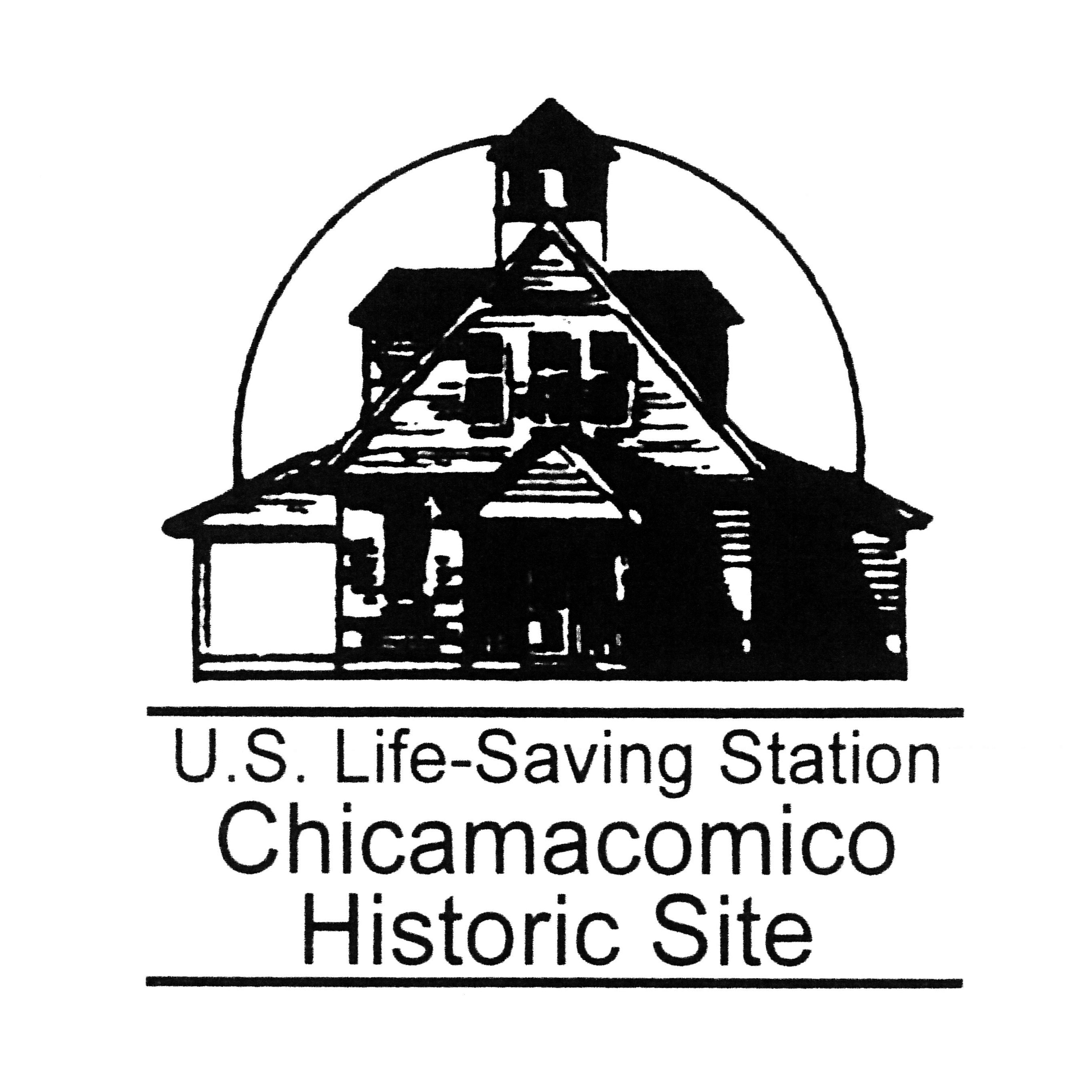
Chicamacomico Historical Association Corporate Sponsorship Form

Why become a sponsor of the Chicamacomico Historical Association?
- Sponsorship includes the satisfaction of knowing you have helped preserve this incredible piece of American history.
- Sponsorship includes quarterly newsletters to keep you updated on restoration and other projects, invitations to special events
- Support educational programming at the station.
- Sponsors are requested to identify themselves when they are visiting the Chicamacomico Historic Site.
- Sponsorship allows use of the facilities for special occasions at a reduced rate.
- Sponsorships are tax-deductible.
- Sponsorship renewal courtesy notices will be e-mailed to you automatically each year, and are generally due by April 1st. Thank you for your Sponsorship!
CORPORATE SPONSORSHIP AT EVERY LEVEL OF GIVING
Become a Corporate Sponsor of the Chicamacomico Life-Saving Station and contribute to the preservation of history on Hatteras Island.

Sustainer $100
Gold Medal $250
Superintendent $500
Admiral $1000

Donors of $5,000 or more will have their logo linked from the footer of the website which appears on every page.

Your contributions to the Chicamacomico Historical Association, a 501(c)(3) nonprofit organization is tax deductible. The Chicamacomico Historical Association does not provide any goods or services to you in consideration of your contribution. Our tax ID number is 23-7441279. To become a member, complete below and mail check to:

Chicamacomico Historical Association
P.O. Box 5
Rodanthe, NC 27968-0005

NAME: _____________________________________________________________
ADDRESS: __________________________________________________________
CITY: __________________________________ STATE: ______ ZIP: ____________
PHONE: ____________________ CELL PHONE: ____________________________
EMAIL: _____________________________________________________________
Your contributions to the Chicamacomico Historical Association, a 501(c)(3) nonprofit organization is tax deductible. The Chicamacomico Historical Association does not provide any goods or services to you in consideration of your contribution. Our tax ID number is 23-7441279.

